Community Forestry Program of Sri Lanka

Progress Report
(August 2012- December 2012)

Implemented by
Forest Department of Ministry of Environment
Sri Lanka
Table of Contents

Project Summary Table 1
Executive Summary 2
Project Description 3
Situational Analysis 5
Relevance 6
Expenditure summary 7
Project Progress 7
Effectiveness 7
Efficiency 7
Monitoring and Evaluation 9
Gender Aspects Considered in the Project 9
Cross-cutting issues 10
Implementation issues 10
Sustainability 10
Risk Management 10
Recognition of Donor Contribution 10

Project Summary Table

Narrative Summary | Verifiable Indicators | Assumptions | Budget
Goal  To improve the management of natural resources to support livelihoods and contribute to poverty reduction in the dry and intermediate zones | - The increase in agricultural productivity and sustainability of agricultural land  - The area of forest included in the community forestry program  - The reduction in the area of chena cultivated, and reduction in the area of chena cultivated using poor agricultural practices (which accelerates soil erosion)  - The increase in the quantity and quality of timber produced from both woodlots and home gardens  - Preparation of an exit strategy within two years of commencement of the program  - Increased income of direct beneficiaries  - Increased savings  - Reduction in poverty (including analysis of who participates in program activities)  - Gender impacts on the division of labour, access to resources and income levels | - Program activities are implemented in areas with a relatively high incidence of poverty.  - Low income levels are a major factor contributing to poverty in the target areas.  - A wide sector of the community participates in program activities.
Component 1: Community Forestry  Objective: To reduce deforestation and forest degradation by involving communities in forest management. | - The change in the forest resource (biodiversity, species composition and volume of the forest stand)  - The extent of forest cover  - Frequency & extent (ha) of forest fires  - Frequency of forest offenses reported (eg. Illegal use or extraction of forest resources)  - Voluntary community inputs to reduce fire | - Unusually dry conditions do not cause catastrophic fire events in the target areas.  - Conflict within the community does not jeopardise Program achievements (eg. arson). | 2,968,400 AUD
Component 2: Institutional Support  Objective: To build the capacity of the Forest Department so community forestry approaches can be implemented nationally. | - Number of community forestry sites and number of districts containing community forestry sites  - Number of direct & indirect beneficiaries  - Estimate of the proportion of time and financial resources allocated to community forestry in each district  - The proportion of successful community forest sites  - Effective monitoring of the program at all levels (district, regional and national) | - Target districts remain suitable for community forestry activities (eg. no return to civil conflict, current knowledge on the extent of land mines is accurate) | 1,401,500 AUD

Executive Summary

The Sri Lanka Community Forestry Program (CFP) , a four year project implemented by the Forest Department of Sri Lanka aims to promote Community Forestry Management (CFM) approach. The project is expected to benefit 90,000 community members living in dry- and intermediate zones of the country and contribute towards increasing the forest cover by 23,000 ha. This program has been developed as the second phase of the Sri Lanka Australia Natural Resource Management Project. The Program is financially supported by the government of Australia and management support is provided by UNDP Sri Lanka.

The project activities were initiated in August 2012 and this report includes the progress of the first four months of implementaion. Among the key achievements in the year 2012 included initiation of 24 new sites in 15 districts; initiation of 2,937 home gardens in new project locations; initiation of work in 465 home gardens in project locations exist before the initiation of the project; establishment of the project office in Forest Department premises; Launching of the project website (www.communityforestry.lk); recruitment of project staff and initiation of a number of key procurements to support project work. The first Project Board meeting was held in 13th December 2012 where the progress was reviewed; challenges and adjustments have been discussed and adopted; and the year 2013 work plan was approved.

The financial delivery of the project is expected to be around 20 % of the total allocation for the year 2012, primarily due to the delays in Government Approval of the project that took more than eight months. Nevertheless it is expected that the project will be able to achieve expected results within the stipulated time frame.

The program plans to accelerate implementation in year 2013 and steps have been taken to expedite the work in the 15 project districts. With the improved access in the Northern Province the project board recommended to expand the project area to include a number of districts in the Northern Province in 2013. Expected Project financial delivery in 2013 is USD approximately 1,600,000 USD.

Project Description

Based on the experience of the Sri Lanka Australia Natural Resource Management Project (SLANRMP) implemented over a 6 year period from February 2003 to January 2009, in late 2008, the Forest Department of the Government of Sri Lanka (GoSL) prepared a Strategy for Community Forest Management (CFM). Further Australian assistance was sought to implement the CFM strategy as a national program.

With the approval of the Australian assistance requested, phase II of the Program titled Sri Lanka Community Forestry Program (CFP) started in August 2012. The goal of CFP is to improve the forest cover by additional 23,000 hectares in dry and intermediate zones while supporting nearly 90,000 community members through Program activities. The project also supports improving the management of natural resources, livelihoods and contribute towards poverty reduction to ensure sustainability. The project has two key components:

- Developing, supporting and implementing Community Forest Management Plans in selected sites
- Institutional Strengthening of the Forest Department to implement Community Forestry approach
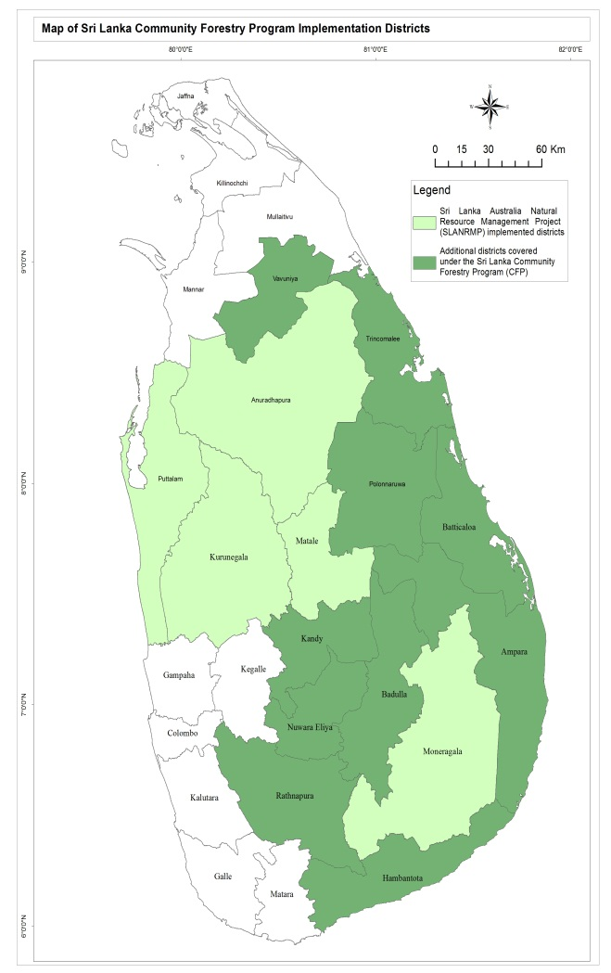
Figure 1: Map of Sri Lanka Community Forestry Program Implementation Districts
Component 1 aims to reduce deforestation and forest degradation via the Community Forest Management (CFM) approach. The CFM approach is a process in which a community is mobilised; natural resource management (NRM) options and priorities identified; and government and/or private sector resources mobilised to implement the priorities. The CFM approach has been endorsed by the Cabinet of Ministers as a national model to be replicated in all forested areas.

Component 2 aims to build the institutional strength of the Forest Department to support the implementation of the CFM. This requires training, resource, advocacy and technical support and policy inputs. The CFP will help the Forest Department to institutionalize and mainstream CFM within the Forest Department and outside.

As shown in the Map 1, the CFP will cover ten (10) additional districts (dark green) which were not covered under the earlier SLANRMP initiative.
Map 1: Project Locations of the Sri Lanka Community Forestry Program

The community forest management (CFM) approach – promoted during SLANRMP – recognises that economic alternatives are necessary if communities are to stop exploiting the forest or cultivating chena in forest areas. Furthermore, the approach recognises that the communities themselves are in a better position to protect the forest from illegal or unsustainable practices, or from fire.

Table 1 provides the adoption of CFM during SLANRMP (2002-2008) and continuation by the Forest Department between 2007 to 2009 and the proposed expansion under the CFP. At the end of the CFP a total number of 15,000 households consisting of 140,000 individuals are expected to be benefited from the assistance.

Table 1: Existing & Proposed Community Forestry Sites
 | SLANRMP  2002-8 | Forest Dept  2007-9 | Expansion  2011-16 | Cumulative Total
Number of districts | 5 | 9 | 15 | 15
Number of sites | 55 | 24 | 167 | 241
Area of forest (ha) | 7,388 | 4,255 | 23,000 | 34,000
Participating households | 3,719 | 1,680 | 10,000 | 15,000
Total beneficiaries | 37,000 | 13,000 | 90,000 | 140,000

The districtwise breakdown of the 167 news sites for the CFP is given in Table 2. In addition the project may expand into the districts in the Northern Province in addition to the Vavuniya district identified during the design phase.

Table 2: CFP Home Garden Development Sites in different Districts

Activity/District | 2012 | 2013 | 2014 | 2015 | Total
Kurunegala | 3 | 3 | 3 | 1 | 10
Matale | 3 | 3 | 2 |  | 8
Puttalam | 3 | 5 | 4 | 2 | 14
Anuradhapura | 3 | 4 | 4 | 3 | 14
Monaragala | 3 | 5 | 3 | 3 | 14
Badulla | 4 | 6 | 5 | 3 | 18
Ampara | 3 | 6 | 5 | 4 | 18
Polonnaruwa | 3 | 5 | 5 | 4 | 17
Ratnapura | 3 | 5 | 3 | 3 | 14
Trincomalee | 1+Traning & home gardens | 1+Training & home gardens | 2 | 2 | 6
Batticaloa | 1+Training & home gardens | 2 | 2 | 3 | 8
Vavuniya | 1+Training & home gardens | 1+Training & home gardens | 1 | 1 | 4
Hambantota | 1+Training & home gardens | 2 | 2 | 2 | 7
Nuwara Eliya | 1+ Training & home gardens | 2 | 3 | 2 | 8
Kandy | 1+Training & home gardens | 2 | 2 | 2 | 7
Total CFM sites | 34 | 52 | 46 | 35 | 167

Situational Analysis

The Forest Department has the mandate to reduce deforestation and forest degradation in the country. The traditional “policing” role adopted by the Department was proved unsuccessful. Despite the introduction of a logging ban in natural forests in 1990, an average of 14,900 ha or 1.3 per cent of the country’s forest area were deforested annually between 1992 and 1999. Geographically, the majority of deforestation occurs in the dry and intermediate zones and the Forest Department estimates an annual deforestation to be around 5,000 hectares or 0.8 per cent per annum.
The concept of community forestry was first introduced through the National Forest Policy in 1980 where it states that Community Forestry “to involve local communities in the development of private woodlots and forestry farms through programs of Social Forestry”. This concept was further developed in the National Forest Policy of 1995 by incorporating the development of partnerships with local communities, community management of forest resources and benefit sharing. The policy statement on the Management of State Forest Resources clearly states that the State will form partnerships with local people and rural communities and introduce appropriate tenurial arrangements for management and protection of forests and to share the benefits.
The Forestry Sector Master Plan (1995), which was built on the National Forest Policy, presents a comprehensive long term development framework for the Forestry Sector from 1995 to 2020. The Master Plan gives particular emphasis on building partnerships and empowering rural communities to manage and protect forest resources, and also to involve communities in forestry development activities and share benefits. The community participation is one of the main strategies identified to achieve the goal on Ensuring Environmental Sustainability in the Millennium Development Goals set out by the Government of Sri Lanka.
With the ending of the internal conflict in May 2009 the Sri Lanka Development Policy Framework “Mahinda Chintana” was revisited with the theme “Sri Lanka – the Emerging Wonder in Asia.” The strategy advocate for a rapid economic growth and a change in the structure of the economy to a modern, environmentally friendly and well connected rural-urban economy that create better-remunerated employment opportunities. The new document identified specific targets aiming at achieving the MDG goals ahead of time. One of the targets is to increase the forest coverage from 28 per cent to 43 per cent by 2016.
To complement the “Mahinda Chintana”, the National Green Strategy or “Haritha Lanka” released in 2009 by the National Council of Sustainable Development headed by H.E. the President further highlighted the appropriateness of the activities of the Program in three of its ten chapters, namely, the Mission 2 on Saving the Fauna, Flora and Ecosystems; Mission 3 on Meeting the challenges of climate change and Mission 5 on Responsible Use of the Land Resources.

Relevance

Deforestation and forest degradation both (i) contributes to poverty and (ii) are a consequence of poverty. Deforestation and forest degradation decrease the livelihood resources available to rural households; decrease the availability of water; increase the time taken to collect fire wood, materials for agricultural production (such as stakes and trellises), water, and to feed livestock; and simultaneously increase risks relating to drought and fire. Yet, the presence of poor households contributes to deforestation and forest degradation, as some poor households, particularly those with limited agricultural land, may either extract resources from existing forest at unsustainable levels or clear forest areas for agricultural purposes. The population density in Sri Lanka is among the highest in Asia (322 people/km²). While many areas of remnant forest have been cleared for agricultural purposes, the chena (land cleared through shifting cultivation) is often of marginal quality for agriculture or is farmed in a way that accelerates soil erosion. The rapid increase in deforestation in the Northern Province to facilitate reconstruction of war-devastated infrastructure highlights a real need to extend CFM practices to that region as soon as possible.
Forest Department has suggested a rapid program to arrest this situation. The proposed Program is based on the presumption that deforestation cannot be compensated for by simply planting trees, hence, the project approach considered ecological, social and economic problems associated with the deforestation in the project design
CFM approach has successfully enhanced the livelihoods of participating communities and reducing the incidence of poverty in Sri Lanka’s dry and intermediate zones, while simultaneously addressing the leading causes of deforestation and forest degradation through;
- Providing alternative livelihoods (including more intensive agriculture) to reduce the need for deforestation as a result of shifting cultivation;
- Assigning management responsibility to communities for specific forest areas has helped control the illegal extraction of timber or the unsustainable harvesting of NTFPs;
- Assigning management responsibility to communities for specific forest areas, along with awareness and fire control measures, has effectively reduced the frequency of fires;
- Improving home gardens have provided a source of timber, materials for stakes and trellises, and firewood, that is easier to collect and helps avoid forest degradation (in addition to the food and income generation benefits of home gardens); and
- Developing woodlots providing a source of income and helps meet the demand for timber in Sri Lanka
The above interventions and best management practices could also help forest communities meet the challenges of potential climate change impacts such as increased temperature and prolonged droughts in intermediate and dry zones of Sri Lanka.

Expenditure summary

The total estimated expenditure for CFP for 2012 was 851,798 USD based on the Annual Work Plan prepared in January 2012. However due to the late start in August 2012, the expenditure level is much lower than the expected with an estimated amount of USD 160,000.

After the project was approved, an advance of 18,980,000 LKR (USD 143,461) was released to the Forest Department via the Treasury in October 2012. The Forest Department expenditure at the end of the year 2012 out of the advance is 9,563,401 SL Rs (USD 73, 564).

The expected expenditure for 2012 via UNDP was 259, 423 USD. Again due to the delay in start only USD 67,712 has been utilized for the project activities.

As the intended vehicle procurement did not take place the Government financial contribution by way of tax etc was Nill although the Forest Department had allocated 40 Million Sri Lankan Rupees in the 2012 budget as per the Project Design document.

Project Progress

The Community Forestry Program that was designed in 2009 was delayed due to a number of reasons and formal approval to implement the CFP through UNDP was granted in mid 2012. Project officially was initiated on 01st of August 2012.

Effectiveness
A number of activities have been commenced within this short period of time of project operation. This can be considered as an indicator for the commitment of the Forest Department to implement the project effectively. Highlights of the implemented project activities are as follows;
- Establishment of financial management procedures.
- Establishment of project office and recruitment of officers;
- Procurement of office furniture and other equipment;
- Commencement of community mobilisation;
- Training of forestry Extension Officers;
- Development of 3,402 home gardens; and
- Initiation of forestry activities in 24 sites

Efficiency
Considering that above achievements were made within several challenges in the operational environment, efficiency of the project implementation can be categorized as satisfactory. Amongst the key challenges in the operational environment,following were critical to the project progress.
- Staff changes in FD management experienced at the initial stages of the project.
- Considerable delay caused in program initiation. As a result, project targets have been reduced and expenditure was low in 2012. FD intends to cover two year targets (2012 and 13) under the 2013 implementation plan.

During the first four months the project carried out the initial ground work including:

- Establishment of the Project Office and Project Board

The FD provided adequate space to establish the Project Office within the FD premises. UNDP procured the IT equipments (compute, projector and printers etc.) and furniture while FD provided internet and electricity facilities. The office is equipped with facilities for three staff and a mini conference table for 5-6 participants.

The first Project Board meeting was held on and a number of decisions related to the project was taken:

    - Instead of a full-time sociologist a number of short-term technical assistance on the subject of sociology to be provided via UNDP
    - A comprehensive baseline for the project results will be established
    - Four wheel single cabs will be purchased for the project purposes since it will provide an opportunity to provide facilities for more offices
    - Possible linkages that might exist with the Divi Neguma Program of the government will be explored

- Recruitment of staff

Recruitment of a Program Officer was completed in September 2012. Recruitment of Implementation and Monitoring Expert to be in charge of the project office was completed in December 2012. The recruitment process for Sociologist was modified as per the decision of the NPSC above.

- Community Forestry work initiated in new project sites

The Project supported twenty four (24) new sites in 15 project districts located in six SLANRP districts and 9 new districts, respectively. A total of 2,937 home gardens has been established in new sites and another 465 home gardens in old (SLANRP and FD) sites have were established in old project sites. The work on all these establishments are still on going. Preparation of Community Forest Management Plans.

- Offical Project Launch

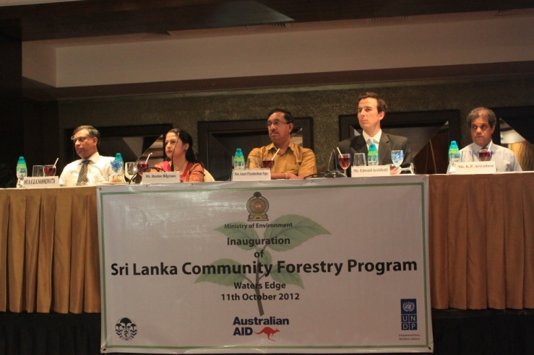
The CFP project was officially inaugurated on 11th October 2012with the participation of Hon. Minister of Environment, Anura Priyadarshana Yapa and other distinguished guests. On the same day the project website – www.communityforestry.lk was also announced.
Figure 2: Distinguished Guests at the Official Launch of the Project at Waters Edge Hotel

The website includes the historical development of Community Forestry Management in Sri Lanka and room for project activities. In addition to the public window the same web page will be used for internal project management where district officers will be able to provide project information via internet. The same information will be used to monitor the project progress by the PCU staff.

- Establishing the financial resources administration mechanism involving the participating districts

UNDP has provided an advance worth of 143,461 USD to Forest Department. This is the first advance processed under the project and therefore it involved familiarization with the UNDP financial resources advance system and the requirements of the Budget Operations Department of the Treasury. Forest Department was able to release resources required for the project work to respective districts only in October 2012.

Since the basic procedures have established there will not be any delays in future to release resources for the project implementation.

- Procurements
Procurement process of 4 single cabs and 45 motor bikes has been initiated through the UNDP. The specifications were developed by the FD taking their operational requirements into account.

Cabs will be delivered to the Department in April 2013 due to unavailability of stocks with the selected manufacturer- Toyota. The tendering process for motorbikes in the Sri Lankan market is underway and the bikes will be delivered to the Department before February 2013.

Monitoring and Evaluation

An online database that can be used for the monitoring of project activities was developed and tested. With the initiation of district level activities in 2013, this database will be used for physical progress monitoring and reporting.

The database has the ability to accommodate institutional requirements of the Forest Department and different levels of authorizations will restrict the inappropriate usage of the database and hence increase the reliability of the system for Work Plan approvals and progress monitoring.

Gender Aspects Considered in the Project
Gender aspects of the project participant selection and decision making process has been recognized as essential components. The project is using guidelines developed by Sri Lanka Australia Natural Resources Management Project (SLANRMP). The guidelines provide clear guidance on the inclusion of gender aspects.

Since the project implementation initiated only two months ago, it is a little early to comment on the results of the gender incorporated programming. To improve the gender related understanding of the project activities and assess the capacity development needs of the Forest Department on the gender related issues with a special focus on the Community Forestry activities, it is proposed to hire a short term Gender Specialist or incorporate gender considerations in the Terms of Reference of the Sociologists to be hired in future.

Cross-cutting issues
Since the project activities started two months ago, the impact of the project on cross cutting issues such as HIV-AIDS, Climate Change, Environment etc. have not been assessed.

Implementation issues
No major operational issues on the project implementation were observed during the project implementation period except for the delayed start of the project. Forest Department is taking steps to rectify the situation by expediting the work and incorporate some of the delayed work in the 2013 Work Plan.

Sustainability
Sustainability of the project activities after the completion of the Program is a key consideration of the Program Design document. It has clearly identified several key areas that needs to be considered in a sustainable project.

- Working with existing GoSL and FD structures;
- CBO approach will promote sustainable livelihood at village level;
- Counterpart contribution (LKR 20 m by GoSL in every year); and
- Combine with other GoSL programs like 'Divi Naguma' etc.
- Development of transition or exit plans.

Risk Management
- Coordination among key three parties (UNDP, FD and AusAID) to be improved.
- Implementation of environmental and social safeguards is also identified as a strategy to manage the risks involved with the project implmeentation.

Recognition of Donor Contribution

AusAID has been recognized in all the knowledge products as per the Communication guidelines issued by the AusAID and UNDP including the project website – www.communityforestry.lk

